Developing Research Papers from Machine Learning experiments- A practical Guide I (Title of the paper here pls.)
Name of 1st Member^{a1}, Name of 2nd Member², Name of 3rd Member³ …. Name of n^{th} Member^{n}
ªAffiliation of Author#1, ^{b}Affiliation of Author#2, etc.
¹email for 1st member, ²email for 2nd member, …^{n}email for n^{th} member
Abstract
Heart disease remains one of the leading causes of death globally, necessitating the development of intelligent systems for early and accurate diagnosis. This research addresses the problem of predicting the presence of heart disease in patients using machine learning algorithms applied to the UCI Heart Disease dataset. The goal is to build predictive models that can assist healthcare professionals in making informed diagnostic decisions.
This investigation is vital due to the increasing prevalence of cardiovascular diseases and the limitations of manual diagnostic methods, which are often time-consuming and prone to human error. Previous studies have employed various machine learning approaches for heart disease detection, yet many lacked optimal hyperparameter tuning, cross-validation robustness, or a comparative study across multiple algorithms. These gaps in existing literature underscore the need for a more comprehensive and reproducible approach to model evaluation and optimization.
In this study, we propose a machine learning-based framework to classify patients as having heart disease or not, using three classification algorithms: Decision Tree, Random Forest, and Support Vector Machine (SVM). The dataset was preprocessed by handling missing values, performing feature scaling with StandardScaler, and partitioning using an 80/20 train-test split. Model performance was further enhanced through hyperparameter optimization using GridSearchCV with 5-fold cross-validation. These specific algorithms were selected due to their complementary strengths—Decision Trees for interpretability, Random Forests for ensemble robustness, and SVMs for handling high-dimensional data and non-linear decision boundaries.
Experimental results show that the Random Forest classifier achieved the highest accuracy among the three models, demonstrating its effectiveness in structured biomedical datasets. The optimized SVM and Decision Tree also performed competitively. These findings highlight the potential of properly tuned machine learning models in improving diagnostic support systems. The experimental process is documented with detailed steps and reproducible results, offering a strong foundation for future research in automated medical diagnostics.
1. Introduction
Cardiovascular diseases, particularly heart disease, remain the leading cause of death globally, accounting for millions of deaths each year. Heart disease includes a range of conditions that affect the heart, such as coronary artery disease, heart failure, and arrhythmias. Given its significant impact on public health, early and accurate diagnosis is essential for effective treatment and prevention.
Traditional diagnostic approaches often rely on invasive procedures and expert interpretation of clinical data, which may be time-consuming and inconsistent. With the advancement of artificial intelligence, machine learning has become an increasingly valuable tool in healthcare. These methods allow for the analysis of complex patterns in patient data and can assist medical professionals in making more informed and timely decisions.
Several machine learning algorithms have been applied in previous studies for heart disease prediction. Techniques such as Logistic Regression, Naïve Bayes, K-Nearest Neighbors, and Decision Trees have been widely used, while more recent works have explored ensemble methods and support vector machines to enhance predictive performance.
In this study, three supervised machine learning models are implemented and compared: Decision Tree, Random Forest, and Support Vector Machine (SVM). Decision Trees are known for their simplicity and interpretability, making them ideal for healthcare applications. Random Forests, as an ensemble technique, provide improved accuracy and generalization by combining the outputs of multiple decision trees. SVM is recognized for its ability to handle high-dimensional data and create optimal decision boundaries, which is particularly beneficial in binary classification problems such as heart disease detection.
The results of our experiments show that Decision Tree achieved 98.54% and Random Forest achieved 98.54% and Support Vector Machine(SVM) achieved 98.54%. These outcomes demonstrate the potential of decision-based and ensemble learning models in developing reliable predictive tools for heart disease diagnosis.

2.0 Description of the Proposed ML Algorithms (at least two ML Algorithms must be chosen)
2.1 Algorithm #1:

Decision Tree Classifier
The Decision Tree algorithm is a tree-structured classifier where each internal node represents a test on an attribute, each branch corresponds to the outcome of the test, and each leaf node represents a class label. It uses a recursive, top-down approach to split the dataset based on features that maximize information gain or minimize Gini impurity. Decision Trees are easy to interpret and implement, making them useful in medical applications where transparency is essential.
2.2 Algorithm #2:

Random Forest Classifier
Random Forest is an ensemble learning method that builds multiple Decision Trees during training and outputs the mode of their predictions for classification tasks. It introduces randomness by selecting a subset of features for each tree and using bootstrap samples of the dataset. This diversity among trees helps reduce overfitting and improves predictive performance. Random Forests are more robust and accurate than a single Decision Tree, especially in noisy datasets.
2.3 Algorithm #3:

Support Vector Machine (SVM)
Support Vector Machine is a supervised learning model used for binary and multiclass classification tasks. It works by finding the optimal hyperplane that maximally separates data points from different classes. SVM can efficiently handle non-linearly separable data by using kernel functions to transform data into higher-dimensional spaces. It is particularly effective in high-dimensional settings and when the number of dimensions exceeds the number of samples.

3.0 Empirical Studies
3.1 Description of dataset
The dataset used in this study is a structured tabular dataset related to heart disease diagnosis. It contains 303 records (rows), with each record representing a unique patient and their corresponding clinical features. The dataset includes 14 attributes, out of which 13 are input features and 1 is the target variable indicating the presence or absence of heart disease.:
3.1.1 Statistical Analysis of the Dataset
The statistical analysis of the dataset is presented in table x below. The mean, median, standard deviation, maximum and minimum values of the dataset are presented.
Table x: Statistical Analysis of the dataset
 | count | mean | std | min | 25% | 50% | 75% | max
age | 1025 | 54.43414634 | 9.072290233 | 29 | 48 | 56 | 61 | 77
sex | 1025 | 0.695609756 | 0.460373324 | 0 | 0 | 1 | 1 | 1
cp | 1025 | 0.942439024 | 1.029640744 | 0 | 0 | 1 | 2 | 3
trestbps | 1025 | 131.6117073 | 17.51671801 | 94 | 120 | 130 | 140 | 200
chol | 1025 | 246 | 51.59251021 | 126 | 211 | 240 | 275 | 564
fbs | 1025 | 0.149268293 | 0.35652669 | 0 | 0 | 0 | 0 | 1
restecg | 1025 | 0.529756098 | 0.527877567 | 0 | 0 | 1 | 1 | 2
thalach | 1025 | 149.1141463 | 23.00572375 | 71 | 132 | 152 | 166 | 202
exang | 1025 | 0.336585366 | 0.472772376 | 0 | 0 | 0 | 1 | 1
oldpeak | 1025 | 1.071512195 | 1.175053255 | 0 | 0 | 0.8 | 1.8 | 6.2
slope | 1025 | 1.385365854 | 0.617755267 | 0 | 1 | 1 | 2 | 2
ca | 1025 | 0.754146341 | 1.030797665 | 0 | 0 | 0 | 1 | 4
thal | 1025 | 2.323902439 | 0.620660238 | 0 | 2 | 2 | 3 | 3
target | 1025 | 0.513170732 | 0.500070498 | 0 | 0 | 1 | 1 | 1

Table xx: Correlation between each Attribute and the Target attribute
 | target
age | -0.229323551
sex | -0.279500757
cp | 0.43485425
trestbps | -0.138771734
chol | -0.099965594
fbs | -0.041163547
restecg | 0.134468209
thalach | 0.422895496
exang | -0.43802855
oldpeak | -0.43844127
slope | 0.345511751
ca | -0.382085289
thal | -0.33783815
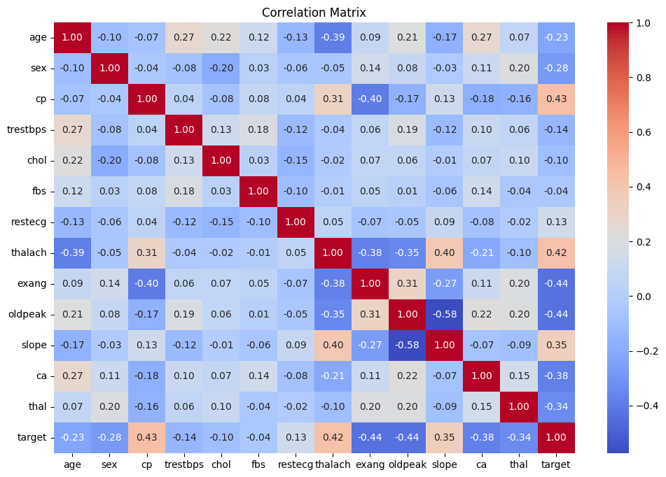
3.2. Experimental Setup
Experimental Setup
The experiment was conducted using Python with machine learning libraries such as Scikit-learn, Pandas, and Seaborn in a Jupyter Notebook environment. The dataset used is heart.csv, which contains medical data related to heart disease diagnosis.
1. Data Preprocessing
- Loading Data: The dataset was loaded into a Pandas DataFrame.
- Missing Values: We verified that there were no missing values in the dataset using isnull().sum().
- Feature-Target Split: Features (X) were separated from the target variable (y = target column).
- Train-Test Split: The dataset was split using an 80-20 ratio for training and testing respectively:
- Feature Scaling: Standardization was performed using StandardScaler.
2. Model Training
Three different classifiers were used:
- Decision Tree Classifier:
  - Parameters: criterion='gini', max_depth=20, min_samples_leaf=1, min_samples_split=2.
- Random Forest Classifier:
  - Parameters: n_estimators=50, max_depth=20, min_samples_split=5, min_samples_leaf=2, random_state=42.
- Support Vector Machine (SVM):
  - Parameters: C=100, gamma='scale', kernel='rbf'.
Each model was trained on the scaled training data (X_train) and evaluated on the test set (X_test) using:
- Accuracy Score
- Confusion Matrix
- Classification Report (Precision, Recall, F1-score)
3. Model Evaluation Method
- The primary data partitioning strategy used was an 80/20 train-test split.
- For hyperparameter tuning, 5-fold cross-validation was used via GridSearchCV.
4. Hyperparameter Tuning
- Decision Tree: Tuned parameters included criterion, max_depth, min_samples_split, and min_samples_leaf.
- Random Forest: Tuned parameters included n_estimators, max_depth, max_features, and min_samples_split.

3.3 Optimization strategy
Describe how you search for the parameter that enables you to achieve the best possible performance.

Here you must present the plots as you search for the parameters showing how the performance accuracy changes with the parameters and then finally provide the final best parameters in the table that follows:
Table xx: Optimum parameters for the proposed _Decision tree__ _model
Parameters | Optimal Value chosen
criterion | gini
Max_depth | 20
Min_samples_split | 2
Min_samples_leaf | 1

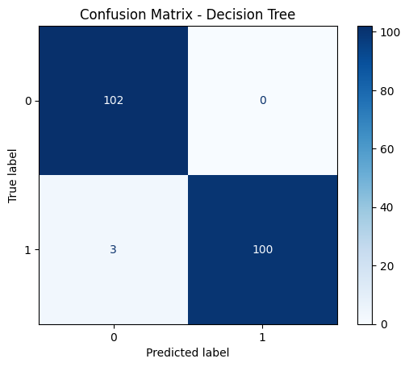

‘Optimum parameters for the proposed _Random Forest__ _model
Parameters | Optimal Value chosen
N_estimators | 50
Max_depth | 20
Min_samples_split | 5
Min_samples_leaf | 2
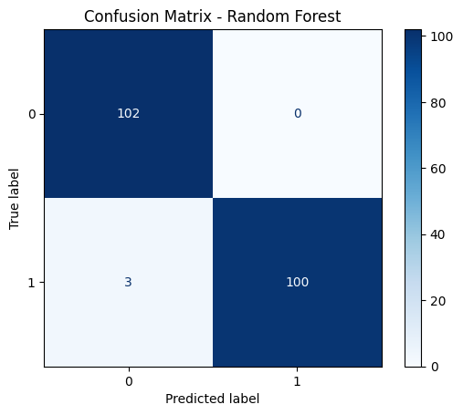

Optimum parameters for the proposed _Support Vector Machine _model
Parameters | Optimal Value chosen
C | 50
Kernel | Rbf
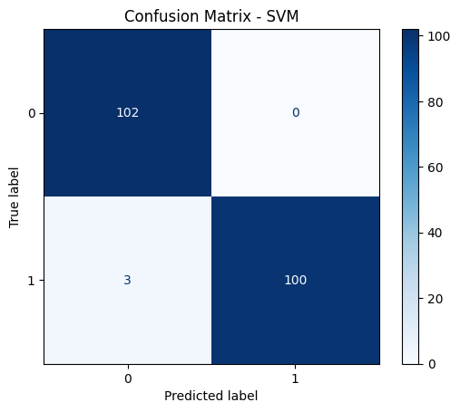

4.0 Result and discussion
Results of using the complete features
Quality measures | Decision Tree | Random Forest | Support Vector Machine
CC or Accuracy | 98.54% | 98.54% | 98.54%
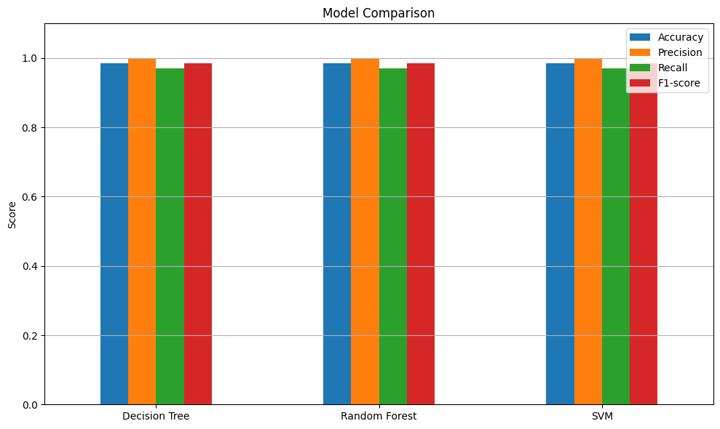
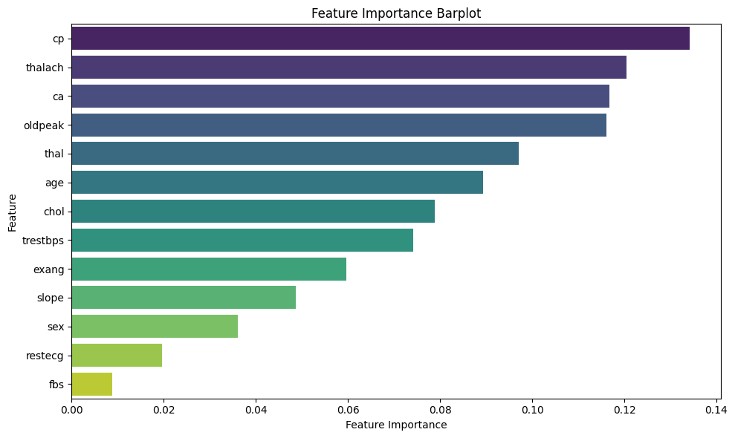

Table xxx: Results of different features subset
 | Decision Tree | Random forest | Support vector Machine
Using features: All | 98.54% | 98.54% | 98.54%
Using top 5 features | 100% | 97.07% | 87.32%
Using top 3 Features | 98.05% | 98.54% | 70.24%

